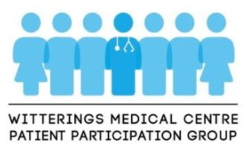

**NEWSLETTER**

**SPRING 2023**



Dear All,

Well, Spring has sprung, though with all the wet weather we have had, it seems to have sprung a leak! I am sure we are all looking forward to some dry, sunny and warmer weather to ward off the winter ills. There seem to have been a lot of nasty coughs and colds about, leading to chest infections, some of which have appear to have affected people much worse than Covid.

I hope you find this Newsletter informative and of interest. Dr Tunicliffe has given a helpful update on developments in the appointments system in his message, which should provide more scope and flexibility for patients in the future. There’s lots of dates for those who want to attend Dementia and Carers Group Meetings and there is the opportunity to have your say on a proposed new Stroke Unit and any experience you may have had as an Outpatient. However, I am disappointed to see, yet again, the number of patients who did not attend their appointments, thus denying those who really needed them.

The final piece of news is that there are some changes on the PPG Committee. Michael Chater, after many years of valuable service as Vice-Chair, is stepping down. I am also stepping down after nearly 5 years on the Committee – so this is the last Newsletter you will receive from me. I am most grateful for all the support I have had from all the members of the Committee and the Medical Staff during my term in the Chair. I am being succeeded by Lesley Mair, who joined the Committee recently, and I have every confidence she will ensure the good work of the PPG carries on. I wish her every success.

It just remains for me to wish you all good health and happiness and have a very enjoyable Easter.



Clive Barrington  
CHAIRMAN (Outgoing)

**IN THIS EDITION**

* Message from Dr Kieran Tunnicliffe
* New contact system to replace eConsult
* Donations from Parish Councils for surgery equipment
* Easter Surgery Closing times
* Non-attendance of Appointments
* Dementia coffee morning dates
* Carers Support Group meeting dates
* Patient Information Centre
* Consultation on new Acute Stroke Unit at St Richard’s hospital
* Workshops on Outpatient Experience

______________________________________________________________________________________________

**Message from Dr Kieran Tunnicliffe (Senior Partner)**



Firstly, the medical centre would like to make public its gratitude to Clive Barrington and Michael Chater who have chaired and vice-chaired, respectively, the Patient Participation Group over recent years. Their diligent work has fostered stronger relations and enabled improved means of communication between the practice and patients and vice versa. This is hugely important work as we strive to improve interaction with our community. A new Chair has been announced and we look forward to building on the work of Clive and Michael in the future.

Thank you for your ongoing patience with regard to the proposed new appointment system. Unless there are any reasons highlighted in the new general practice contract which the government is about to impose upon us, we plan to commence the new appointment booking system on Tuesday 2nd May.

The new system will have a number of on the day appointments available with our new “on the day” duty team who will initially discuss problems over the phone before arranging, where necessary, a face-to-face appointment at the medical centre.

Additionally, we will be re-introducing pre-bookable appointments. Patients will be able to choose whether these are face-to-face or by telephone. These appointments will be available up to 2 weeks in advance.

We are also working on a “signposting tool” which will enable receptionists and care-coordinators to ask selected questions about your problem to ensure that you are managed by the most appropriate clinician first time. In the same way that when patients call 111 or check in at A+E they are asked clinical questions by trained administrative staff. We are conscious that some patients might be apprehensive about this but we want to assure you that all members of staff are bound by the same high levels of confidentiality as the doctors & nurses. It is important to stress that sometimes, the most appropriate means of contact might not be with a doctor at the medical centre. The government has been resourcing local community pharmacies to see minor ailments in addition to funding clinical services that must be provided for the entirety of Chichester (examples of these are the GP Access Hub and the remote Dr Morten’s specialist women’s health service).

We will be publishing more information regarding the new system in coming weeks.

Finally, the practice has recently employed the services of an organisation who have performed a “deep dive” to look at our processes and perform a demand and capacity assessment to see where we might be able to further improve the practice for our patients.

Wishing you all a lovely Easter,

Dr Tunnicliffe

**NEW PATIENT TRIAGE SYSTEM TO REPLACE eCONSULT**

A new web-based online consultation system (called Accurx) is to be introduced in April to replace eConsult. This tool will allow patients to submit a much shorter and simpler medical or admin query directly to the Medical Centre. It is replacing eConsult which was felt by many to be too long-winded, requiring a lot of information before getting to the issue the patient wanted to raise.

It is hoped this new system will reduce the number of patients calling for non-urgent appointments.

**PROBLEMS WITH GETTING A CALL BACK?**

**If you have used the call back facility when you have rung for an appointment and are still**

**awaiting a call, please DO NOT RING BACK AGAIN, otherwise this will cancel the call back**

**which you originally logged with the surgery.**



**LOCAL PARISHES FUND MEDICAL EQUIPMENT**

The Medical Centre is very grateful to all the Parish Councils – East Wittering & Bracklesham, West Wittering, Earnley, West Itchenor & Birdham - for their very generous contributions which have enabled the purchase of new equipment and will meet the service costs of existing equipment. The money is actually channelled through Friends of the Medical Centre, which is a registered charity, and will be spent on maintaining the retinopathy machine and purchasing a new ECG machine amongst other pieces of valuable equipment.

These items are expensive and are not part of the standard equipment provided to surgeries by the NHS, but having them on site means that diagnosis can be carried out at the surgery, thereby saving patients the inconvenience of having to travel to the hospital and possibly having to wait for results.

**If you would like to make a donation to help with the cost of equipment which provides such a beneficial service to the patient community then please contact the Practice Manager via reception.witterings@nhs.net**

_____________________________________________________________________________________

**EASTER SURGERY CLOSING TIMES**

**Thursday 6 April CLOSED from 6.30 pm**

**Friday 7 April CLOSED**

**Saturday 8 April CLOSED**

**Sunday 9 April CLOSED**

**Monday 10 April CLOSED**

**Tuesday 19 April OPEN from 8.00 am**

**If you need medical advice when the Surgery is closed**

**Please call 111**

**In case of EMERGENCY please dial 999**

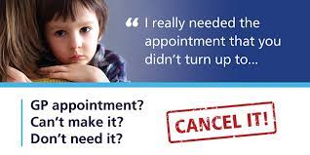

The table below shows the number of appointments carried out during the last three months and the number which were not attended. As can be seen, over the three months, a staggering **54 hours** were wasted. If the average appointment takes 10 minutes, then this means **324** patients could have been attended to in that time.

**2022/23**  **December January February TOTAL**

|  |  |  |  |  |
| --- | --- | --- | --- | --- |
| Did Not Attend/Answer Triage Call | 97 | 67 | 67 | **231** |
| Equivalent in hours lost | 19.5 | 16.5 | 18.0. | **54.0** |

_____________________________________________________________________________________

[](https://witteringsmedicalcentre.us10.list-manage.com/track/click?u=e99b3be5b4a003e606e31f751&id=c58c247caa&e=57ba1c34bd)

**Dementia & Carers Coffee Morning**

**The next meeting is on Wednesday 5th April 10 am - 11.30 am**

**at the Medical Centre**

Dementia Support is a Community Service run by Sage House, City Fields Way, Tangmere PO20 2FP

Tel: 01243 888 691 Email: [info@dementia-support.org.uk](mailto:info@dementia-support.org.uk?subject=Enquiry%20via%20Wittering%20PPG%20Newsletter&body=null) Web: [www.**dementia-support.org.uk**](https://witteringsmedicalcentre.us10.list-manage.com/track/click?u=e99b3be5b4a003e606e31f751&id=2840a40493&e=57ba1c34bd)

______________________________________________________________________________________________





**Meet up at the Caring Café Carers Group in East Wittering**

**An informal group for carers to come together, have a chat and a cuppa!**

**A Carer Wellbeing Worker will be available for support and can help you manage your caring role.**

**No need to book – just come along for peer support and meet other carers.**

**Meeting dates are on a Wednesday**

**10th May, 14th June, 12th July, 13th September 2023**

**between 2.30 pm – 4,00 pm**

**at Calamity’s Café, 11 The Parade, East Wittering PO20 8BN**

**THE WITTERINGS MEDICAL CENTRE CARER CLINIC**

**A drop-in Surgery for Carers in the Witterings and Bracklesham area offering one-to-one support**

**from our Carer Wellbeing Workers and to find out how our services can help you manage**

**your caring role.**

**Meet at the Witterings Medical Centre, 2.00 pm - 3.30 pm**

**Tuesdays 9th May – 11th July – 7th November 2023**

**For further information on both the above:**

**Call: 0300 028 8888 Email: info@carerssupport.org.uk Web: www.carerssupport.org.uk**

**Follow our social media channels to stay up to date with wellbeing information and groups:**

**facebook.com/CarersWSussex – Twitter: @carerswsussex**

**Instagram: @carersSWS – Linkedin: carerssupportwestsussex**

**Registered Charity No. 1123359 Company No. 6418743**

**_____________________________________________________________________________________________**

**Patient Information Centre**

**The Patient Information Centre, located in the Medical Centre reception area, is staffed every weekday morning between 9.30 am – 11.30 am.**

**Here you will find a wealth of information with a wide range of literature on self-help health care and support services which are available locally for carers and patients.**

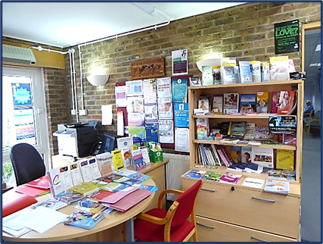

**_____________________________________________________________________________________________________________________**

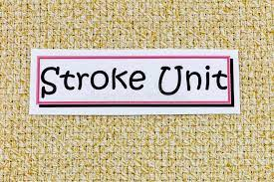

**PROPOSAL FOR NEW ACUTE UNIT AT ST RICHARD’S HOSPITAL**

**At present patients in West Sussex who have a stroke that may require more serious tests and possible neurosurgery would be sent to QA in Portsmouth or Southampton, QA is already at capacity. It is proposed to upgrade St Richard’s Hospital to an Acute Unit and build a new centre in the Royal Sussex at Brighton.**

**There is a public consultation on this proposal which closes on 21st April 2023**

**If you are interested in finding out more information on this, go to**

[Improving stroke services in West Sussex - Sussex Health and Care (ics.nhs.uk)](https://www.sussex.ics.nhs.uk/our-priorities/our-work/improving-health-services/stroke/improving-stroke-services-in-west-sussex/).

You can also complete a questionnaire online at:

www.opinionresearch.co.uk/WestSussexStroke

_____________________________________________________________________________________

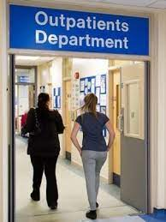

**Are you interested in helping the NHS to improve the Outpatient experience?**

In the last two years, have you, or someone you care for, attended or are waiting for, a Sussex-based Outpatient appointment?

If so, you may like to take part in four online workshops with other local people and the **Sussex Outpatient Transformation team**, to help transform the Outpatient service and ensure it is communicating effectively to patients.

**The Online Workshops are on the following dates:**

**Thursdays: 20th April, 27th April, 4th May, 11th May – 11.00 am – 1.00 pm**

If you are interested & can commit to all four dates,

please contact: [Michelle@HWBH.co.uk](https://www.canva.com/link?target=mailto%3ALester%40HWBH.co.uk&design=DAFa10uaRHI&accessRole=editor&linkSource=document) or **01273 234040**

**You will receive a £100 high street voucher as a thank you.**

Outpatient appointments are usually hospital-based, without an overnight stay, across a wide range of specialities (examples include physiotherapy, Urology and Cardiology)

**_____________________________________________________________________________________**